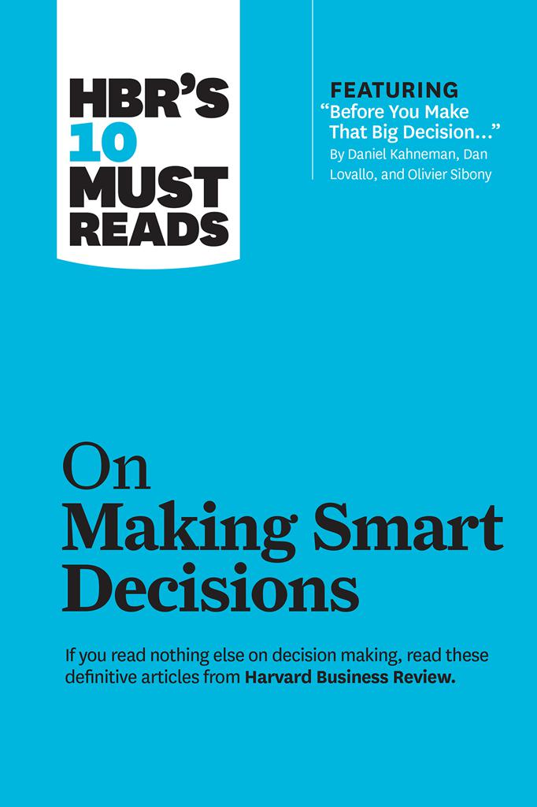

HBR’s 10 Must Reads series is the definitive collection of ideas and best practices for aspiring and experienced leaders alike. These books offer essential reading selected from the pages of *Harvard Business Review*on topics critical to the success of every manager.

**Titles include:**

HBR’s 10 Must Reads on Change Management

HBR’s 10 Must Reads on Collaboration

HBR’s 10 Must Reads on Communication

HBR’s 10 Must Reads on Innovation HBR’s 10 Must Reads on Leadership

HBR’s 10 Must Reads on Making Smart Decisions

HBR’s 10 Must Reads on Managing People

HBR’s 10 Must Reads on Managing Yourself

HBR’s 10 Must Reads on Strategic Marketing

HBR’s 10 Must Reads on Strategy

HBR’s 10 Must Reads on Teams

HBR’s 10 Must Reads: The Essentials

The Hidden Traps in Decision Making *by John S. Hammond, Ralph L. Keeney, and Howard Raiffa*

Before You Make That Big Decision *by Daniel Kahneman, Dan Lovallo, and Olivier Sibony*

How to Avoid Catastrophe *by Catherine H. Tinsley, Robin L. Dillon, and Peter M. Madsen*

Conquering a Culture of Indecision *by Ram Charan*

What You Don’t Know About Making Decisions *by David A. Garvin and Michael A. Roberto*

Who Has the D? *by Paul Rogers and Marcia Blenko*

How (Un)ethical Are You? *by Mahzarin R. Banaji, Max H. Bazerman, and Dolly Chugh*

Make Better Decisions *by Thomas H. Davenport*

Why Good Leaders Make Bad Decisions *by Andrew Campbell, Jo Whitehead, and Sydney Finkelstein*

Stop Making Plans; Start Making Decisions *by Michael C. Mankins and Richard Steele*

***The Hidden Traps in Decision Making***

*By John S. Hammond, Ralph L. Keeney, and Howard Raiffa*

MAKING DECISIONS IS THE MOST important job of any executive. It’s also the toughest and the riskiest. Bad decisions can damage a business and a career, sometimes irreparably. So where do bad decisions come from? In many cases, they can be traced back to the way the decisions were made—the alter- natives were not clearly defined, the right information was not collected, the costs and benefits were not accurately weighed. But sometimes the fault lies not in the decision-making process but rather in the mind of the decision maker. The way the human brain works can sabotage our decisions.

Researchers have been studying the way our minds function in making decisions for half a century. This research, in the laboratory and in the field, has revealed that we use unconscious routines to cope with the complexity inherent in most decisions. These routines, known as *heuristics,*serve us well in most situations. In judging distance, for example, our minds frequently rely on a heuristic that equates clarity with proximity. The clearer an object appears, the closer we judge it to be. The fuzzier it appears, the farther away we assume it must be. This simple mental shortcut helps us to make the continuous stream of distance judgments required to navigate the world.

Yet, like most heuristics, it is not foolproof. On days that are hazier than normal, our eyes will tend to trick our minds into thinking that things are more distant than they actually are. Be- cause the resulting distortion poses few dangers for most of us, we can safely ignore it. For airline pilots, though, the distortion can be catastrophic. That’s why pilots are trained to use objective measures of distance in addition to their vision.

Researchers have identified a whole series of such flaws in the way we think in making decisions. Some, like the heuristic for clarity, are sensory misperceptions. Others take the form of biases. Others appear simply as irrational anomalies in our thinking. What makes all these traps so dangerous is their in- visibility. Because they are hardwired into our thinking process, we fail to recognize them—even as we fall right into them.

For executives, whose success hinges on the many day-to- day decisions they make or approve, the psychological traps are especially dangerous. They can undermine everything from new-product development to acquisition and divestiture strategy to succession planning. While no one can rid his or her mind of these ingrained flaws, anyone can follow the lead of airline pilots and learn to understand the traps and compensate for them.

In this article, we examine a number of well-documented psychological traps that are particularly likely to undermine business decisions. In addition to reviewing the causes and manifestations of these traps, we offer some specific ways managers can guard against them. It’s important to remember, though, that the best defense is always awareness. Executives who attempt to familiarize themselves with these traps and the diverse forms they take will be better able to ensure that the decisions they make are sound and that the recommendations proposed by subordinates or associates are reliable.